> library(ggplot2)
> summary(mpg)
manufacturer model displ year
Length:234 Length:234 Min. :1.600 Min. :1999
Class :character Class :character 1st Qu.:2.400 1st Qu.:1999
Mode :character Mode :character Median :3.300 Median :2004
Mean :3.472 Mean :2004
3rd Qu.:4.600 3rd Qu.:2008
Max. :7.000 Max. :2008
cyl trans drv cty
Min. :4.000 Length:234 Length:234 Min. : 9.00
1st Qu.:4.000 Class :character Class :character 1st Qu.:14.00
Median :6.000 Mode :character Mode :character Median :17.00
Mean :5.889 Mean :16.86
3rd Qu.:8.000 3rd Qu.:19.00
Max. :8.000 Max. :35.00
hwy fl class
Min. :12.00 Length:234 Length:234
1st Qu.:18.00 Class :character Class :character
Median :24.00 Mode :character Mode :character
Mean :23.44
3rd Qu.:27.00
Max. :44.00
> ggplot(mpg,aes(x=displ,y=cty))+geom_point()

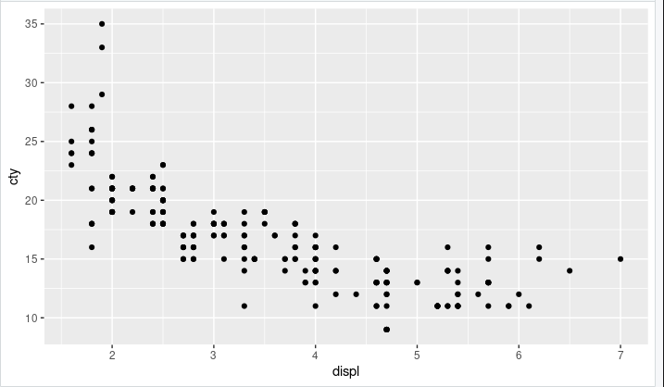

> ggplot(mpg,aes(x=displ,y=cty,colour=class))+geom_point()

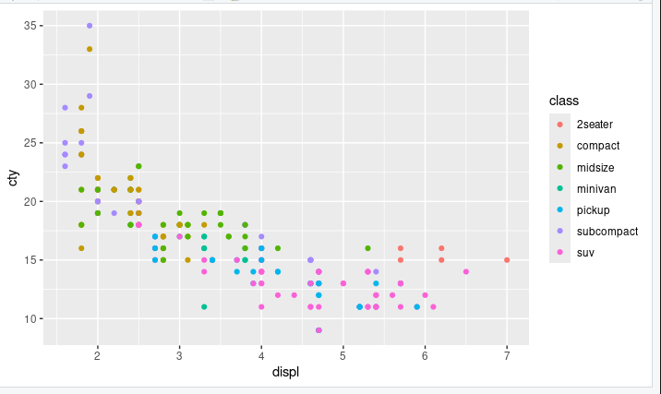

> ggplot(mpg,aes(x=displ,y=cty))+geom_point()+geom_smooth(method="lm")
`geom_smooth()` using formula = 'y ~ x'

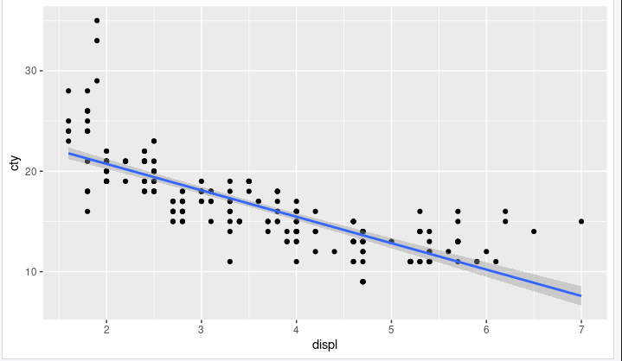
> ggplot(mpg,aes(x=displ,y=cty,colour=class))+geom_point()+facet_wrap(~manufacturer)

